**Feedback Control Systems**

**Lab Report 6**

**Hafiz Ahmad**

**19l-1316**

**Section-6B2**

**Study of Second Order System Analysis using MATLAB**

**INTRODUCTION:**

The steady-state response means the manner in which the system output behaves as t (time) approaches infinity. The transient response means that which goes from the initial state to the final state. In control systems analysis, we frequently need to simplify a network of interconnected transfer functions into a single transfer function which is then used in subsequent calculations for analysis purposes. There are three different types of connections between transfer functions that are usually encountered in practice: cascade-connected, parallel-connected and feedback-connected (closed loop) transfer functions. MATALB has convenient commands to obtain these transfer functions. To obtain the transfer functions of the cascaded, parallel, feedback and unity feedback systems,

**OBJECTIVES:**

* To implement the systems in MATLAB
* To understand the system transient and steady-state responses

**Procedure:**

**Exercise 1**

**a)**

[num,den]= ss2tf([0 1;-6 -5],[0;1],[8 1],[0])

sys = tf(num,den)

step(sys)

***Transfer Function = (8s+1)/(s2+5s+1)***

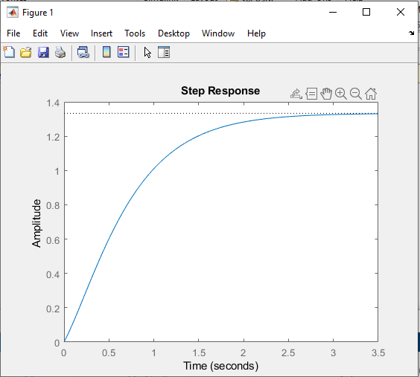

**b)**

[num,den]= ss2tf([0 1 0;0 0 1;-1 -2 -3],[10;0;0],[1 0 0],[0])

sys = tf(num,den)

step(sys)

***Transfer Function =  (10s2+30s+20)/(s3+3s2+2s+1)***

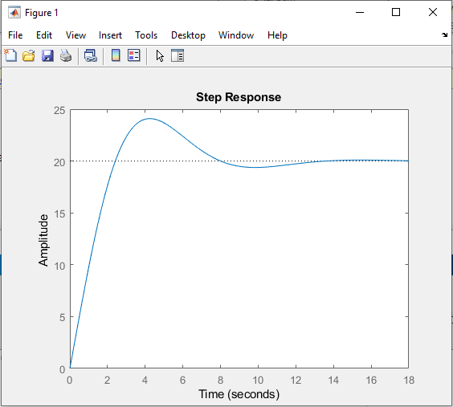

**Exercise 2**

***Transfer Function* =** (wn2)/(s2+2ζwns+wn2)

                                = (5)2/(s2+2(0.4)(5)(s)+52)

                                = (25)/(s2+4s+25)

**Exercise 3**

sys = tf([25],[1 4 25])

ltiview(sys)

stepinfo(sys)

***PeakTime:*** 0.69

***Overshoot*:** 25.37

***RiseTime:*** 0.30

***SettlingTime:*** 1.68

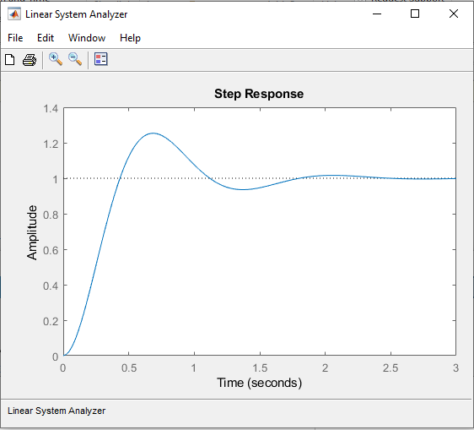

**Exercise 4**

sys = tf([3 25 72 80],[1 8 40 96 80])

[r,p,k] = residue([3 25 72 80],[1 8 40 96 80 0])

ltiview(sys)

stepinfo(sys)

**Output:**

sys =

      3 s^3 + 25 s^2 + 72 s + 80

  --------------------------------

  s^4 + 8 s^3 + 40 s^2 + 96 s + 80

r =

  -0.2812 - 0.1719i

  -0.2812 + 0.1719i

  -0.4375 + 0.0000i

  -0.3750 + 0.0000i

   1.0000 + 0.0000i

p =

  -2.0000 + 4.0000i

  -2.0000 - 4.0000i

  -2.0000 + 0.0000i

  -2.0000 + 0.0000i

   0.0000 + 0.0000i

k =

     []

***RiseTime:*** 0.3693

***SettlingTime:*** 1.9166

***Overshoot:*** 0

***PeakTime:*** 5.0427

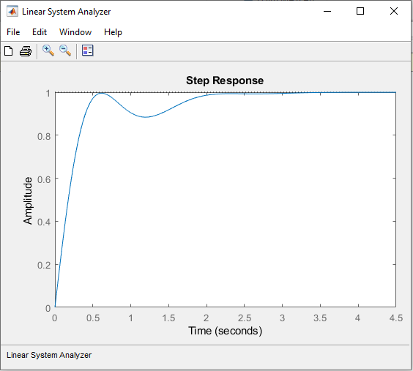

**Exercise 5**

**Unit Step Response**

sys = tf([10 4],[1 4 4])

ltiview(sys)

stepinfo(sys)

***RiseTime:*** 0.0993

***SettlingTime:*** 3.5420

***Overshoot:*** 114.5962

***PeakTime:*** 0.6300

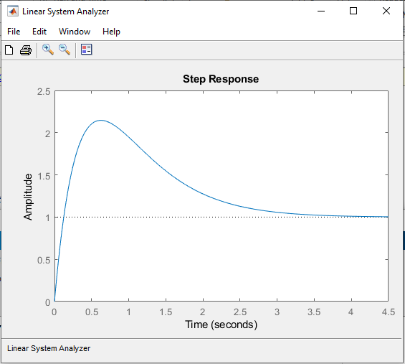

**Unit Ramp Response**

sys = tf([10 4],[1 4 4 0])

ltiview(sys)

stepinfo(sys)

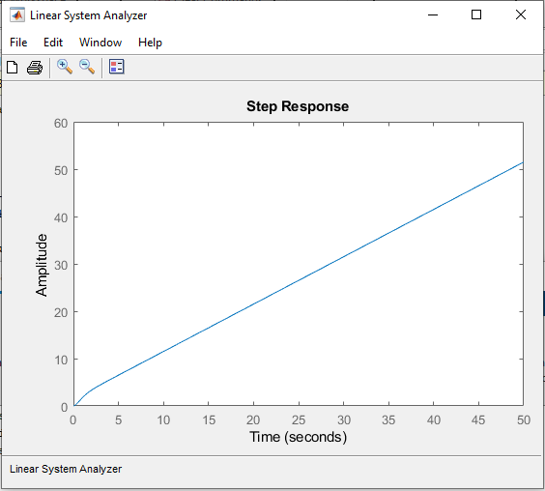

**Exercise 6:**

**Ramp Response**

sys = tf([1 10],[1 6 9 10 0])

ltiview(sys)

stepinfo(sys)

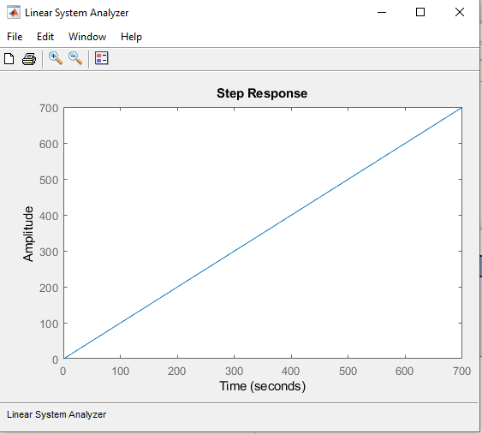

***r=e-0.5tResponse***

sys = tf([2 20],[2 13 24 29 10])

impulse(sys)

stepinfo(sys)

***RiseTime:*** 4.0735

***SettlingTime:*** 8.4321

***Overshoot:*** 0

***PeakTime:*** 14.6444

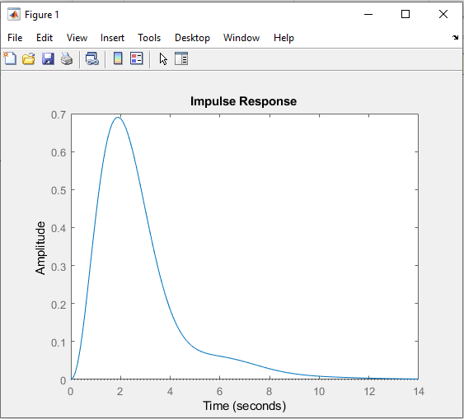

**Exercise 7**

sys = tf([16],[1 4 16])

ltiview(sys)

stepinfo(sys)

|  |  |
| --- | --- |
| **Rise Time:** | 0.4098 |
| **Peak Time:** | 0.8980 |
| **Maximum overshoot** | 16.2929 |
| **Settling Time** | 2.0190 |
| **Value of k** | 0.2 |

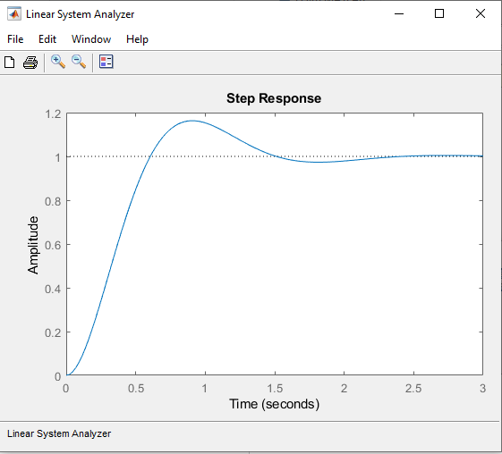

**Application:**

By doing this experiment Steady state and transient responses helps us to understand the working of the system.

**Issues:**

No issue found while performing the lab.

**Conclusion:**

In this lab we learn and we are able to calculate and observe the steady state and transient response of the system and also how to plot them on MATLAB

**Post lab:**

**Q1: Using MATLAB, obtain the unit-step response, unit-ramp response, and unit impulse response of the system defined below. Where R(s) and C(s) are LAPLACE transform of the input r (t) and output c(t) respectively.**



**Q2: Consider the differential equation system given by:**



**Using syms and d-solve commands, obtain the response y(t) subject to the given initial condition. Use MATLAB help to understand these commands.**



